CONFERENCE VENUES & SECURITY
- Thursday evening early registration, reception and lecture by Prof Graeme Barker – American Academy Main Building
- Friday morning registration 8.30-13.00 - AUR Campus Garden
- Conference sessions all day Friday and Saturday – Auditorium Auriana
- Lunch Friday and Saturday - AUR Campus Garden
- Registration after 12.30 on Friday - Auditorium Auriana
- Garden 2 – backup room
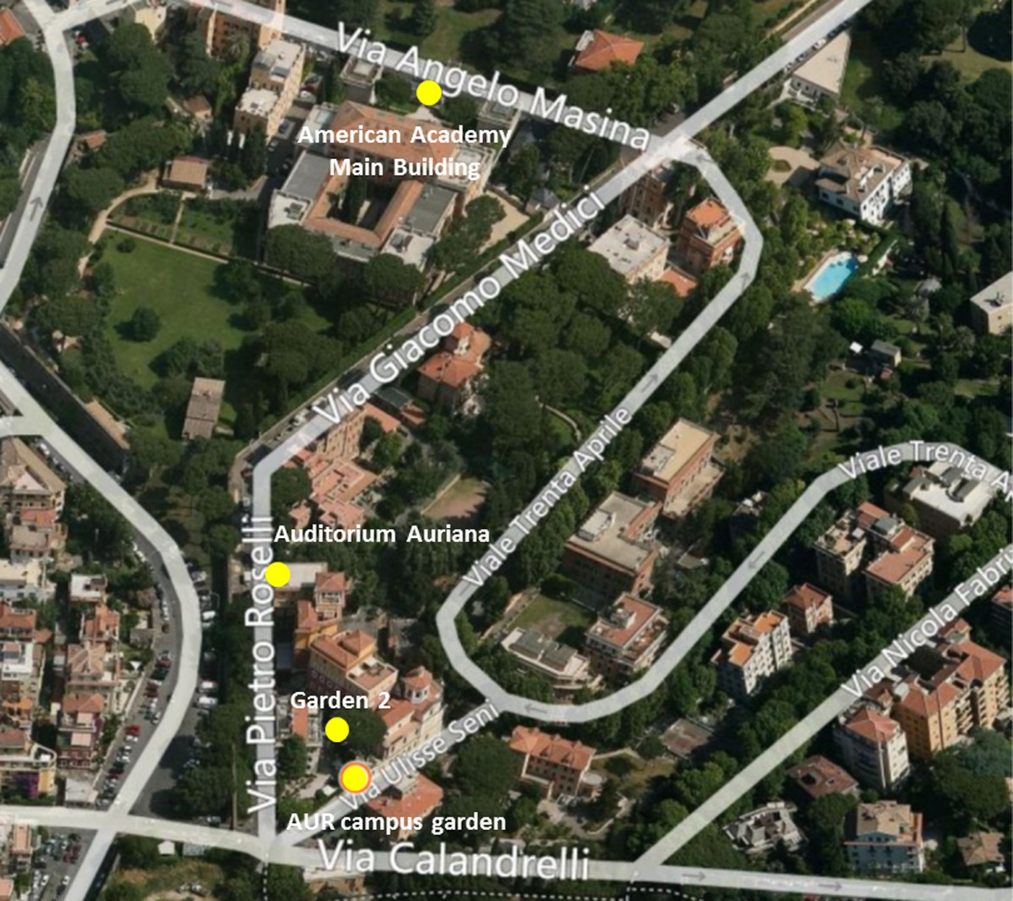
Please bring photo id when you register for the conference (whether you are registering at the American Academy of Rome or the American University of Rome) and please carry it with you at all times. You will be given a conference name badge, please wear it, so that the security staff can identify you. Please be aware that security staff are instructed to be able to identify everyone on the AUR campus, so if they approach you for verification please be co-operative and understand that they are only doing their job, and that the ultimate objective is to ensure everyone’s safety. We will be giving a list of all registered participants to the guards. You will notice that there are Italian soldiers by the gates. These units are part of the “safe streets” campaign which was initiated after the Paris bombings. You will see them at public buildings, metro stations and around all foreign institutions. They are there on the orders of the Italian state and have nothing to do with AUR.

