AUR and the American Academy of Rome are hosts for 37th Annual Conference of Association of Environmental Archaeology entitled ‘Synthesis and Change in Palaeo-Environmental studies in the Mediterranean’
Sept 29 – October 1, 2016.

Travel Information

How to get to The American University of Rome

Address: Via Pietro Roselli, 16 - 00153 Rome, Italy Telephone: +39.06.5833.0919
Morning sessions of the the Conference will be held at the Auriana Auditorium, Via Pietro Roselli, 16 – 00153 Rome, Italy.

Please note that there are two bus lines that can take you to The American University of Rome: 75 (from Termini station), and 44 (from Piazza Venezia).
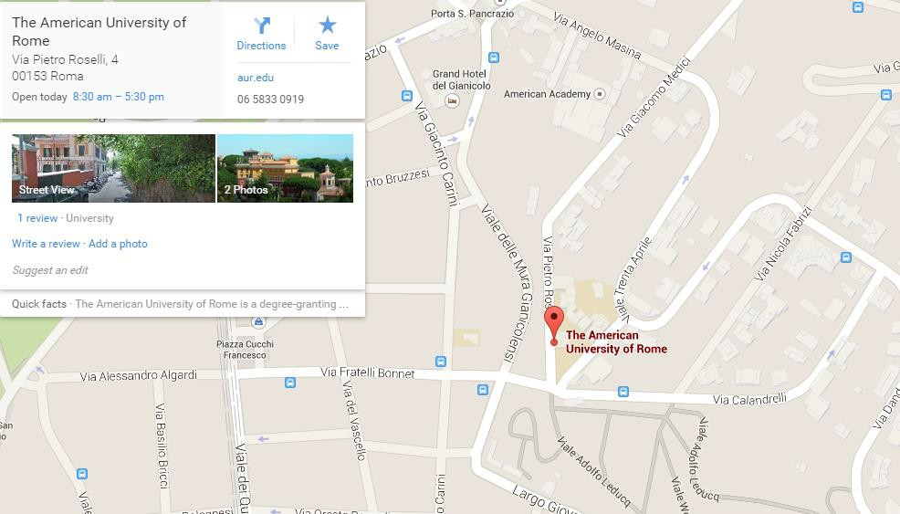

Show large map

Directions from the Airport

Arriving at Fiumicino airport

By Taxi:

If you want to take a taxi from the airport to your hotel know that the standard price is 48 euros, plus one euro for your baggage.

By Bus:

If you are staying close to Termini there is a bus that runs from the Airport to the city center for 4 euros. If you want to purchase your tickets you can go to http://www.terravision.eu/ to get them ahead of time because the buses do tend up to fill up quickly. This ride can usually takes 30 minutes unless there is traffic which will make the ride longer.

By Train:

If you are staying close to The American University of Rome there is a train that goes from Fiumicino to the Trastevere Station. This train leaves almost every 30 minutes and it costs 8 euros.

If you want to purchase your ticket beforehand you can at the Treni Italia reservation website or you can purchase them at the ticket machine before getting on the train. If you are staying close to the city center you can also take a train from Fiumicino to the main train station which is Termini for 14 euros.
The ride for both of these train rides is about 30 minutes.

Arriving at Ciampino airport

By Taxi:

If you want to take a taxi to your hotel from Ciampino airport the set price for this ride is 30 euros and they will charge you an extra euro for your luggage.

By Bus:

If you are staying close to Termini there is a bus that runs from the Airport to the city center for 4 euros. If you want to purchase your tickets you can go to http://www.terravision.eu/ to get them ahead of time because the buses do tend up to fill up quickly. This ride can usually takes 30 minutes unless there is traffic which will make the ride longer.

**There is no train from Ciampino Airport to the city center like Fiumicino airport.**

